PID Tuning Guide

By Scott Lawson

1. Start the TINAH board by connecting the LiPo battery and turning the power on using with the switch (Figure 1). After several seconds, the TINAH board will boot. The tape follower is ready once the booting process is complete. 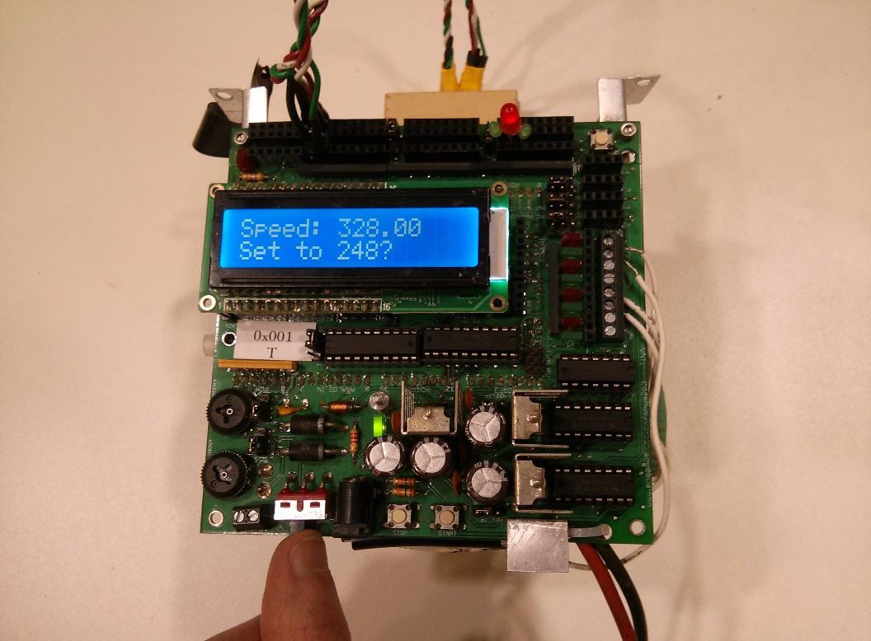

Figure . The power switch is located on the bottom right of the TINAH board

1. Once booted, the TINAH board will display several values on the LCD screen. Each value is a tuning parameter that can be changed to alter the performance of the tape follower. The LCD screen will show one value at a time. To change the displayed value, rotate the upper knob found on the bottom left of the TINAH board. 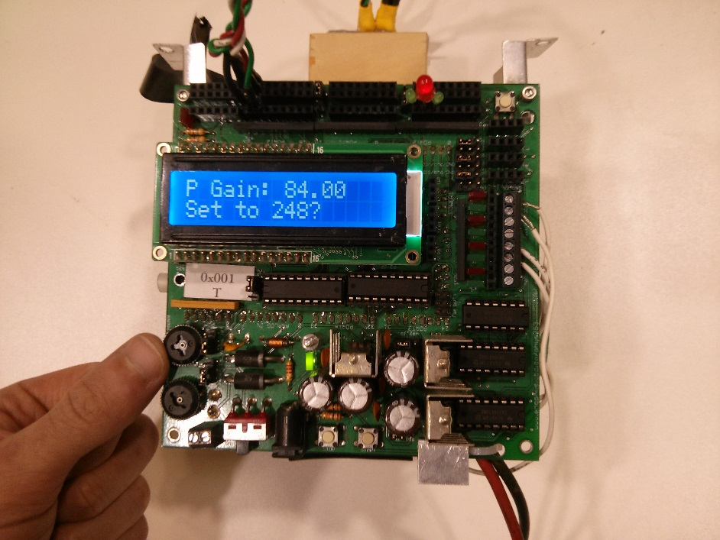

Figure 2. The upper knob allows the user to scroll through a series of tuning parameters

1. The value of each tuning parameter can be changed by rotating the lower knob, found on the bottom left of the TINAH board (Figure 3). The tuning parameters must be integers in the range of 0 to 255. 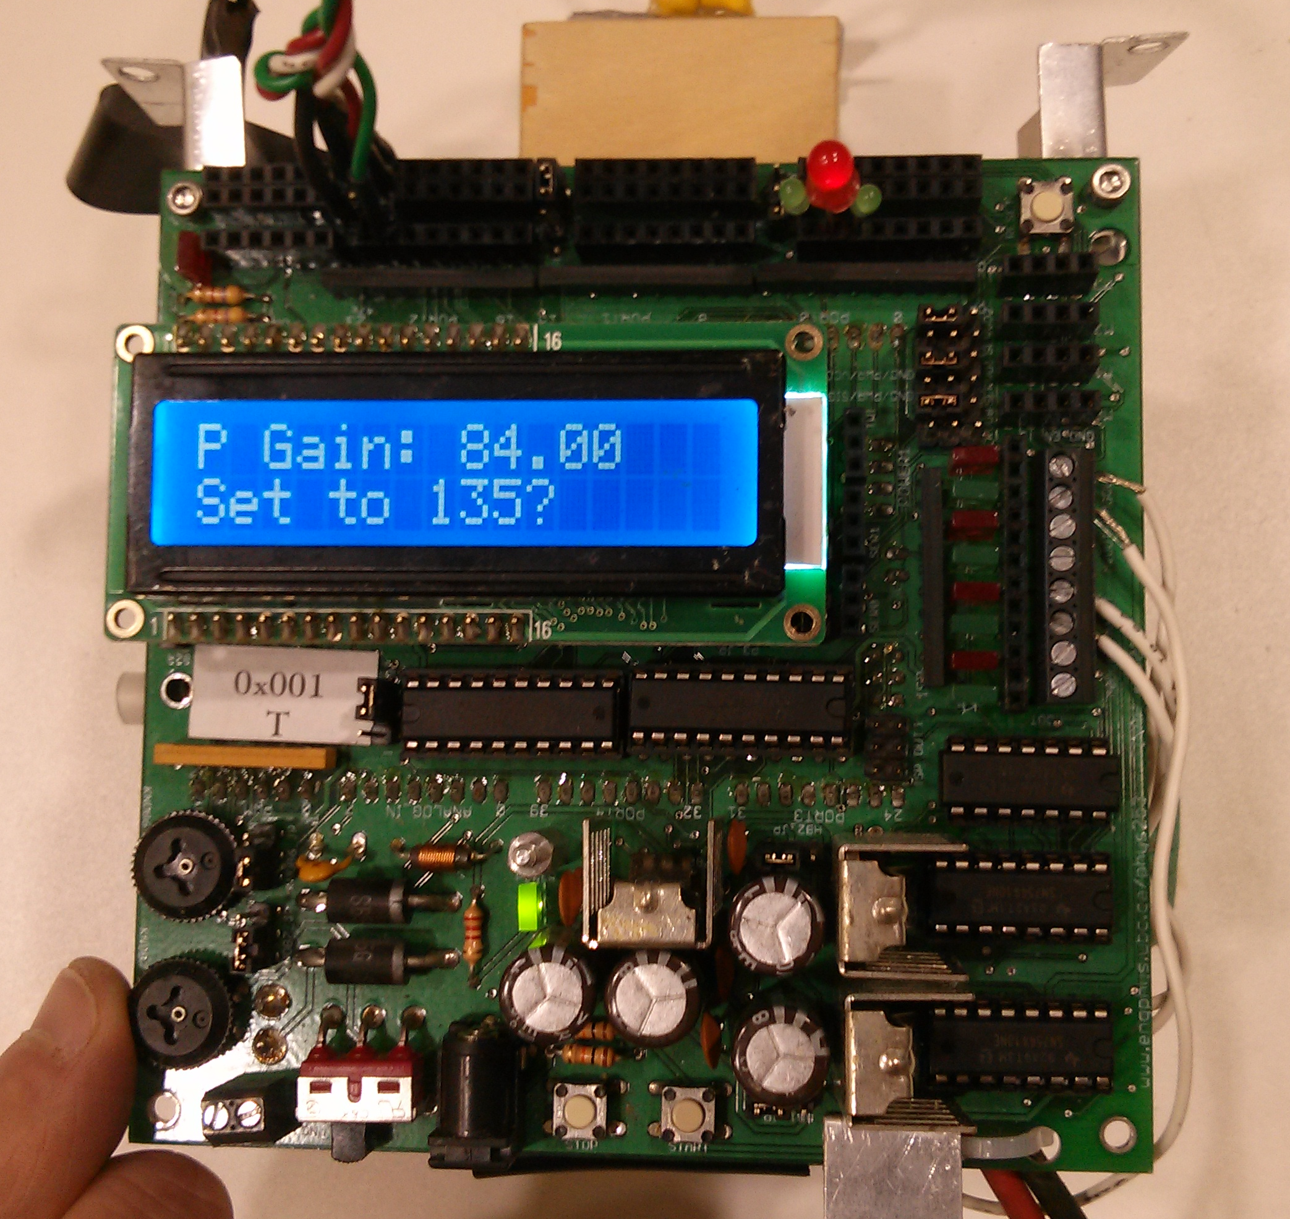

Figure . Rotating the lower knob will adjust the value of the displayed tuning parameter

1. To confirm a tuning parameter value change, press the button found on the bottom left of the TINAH board (Figure 4). This will save the tuning parameter to the EEPROM, and the saved value will be restored even when the TINAH board is restarted. 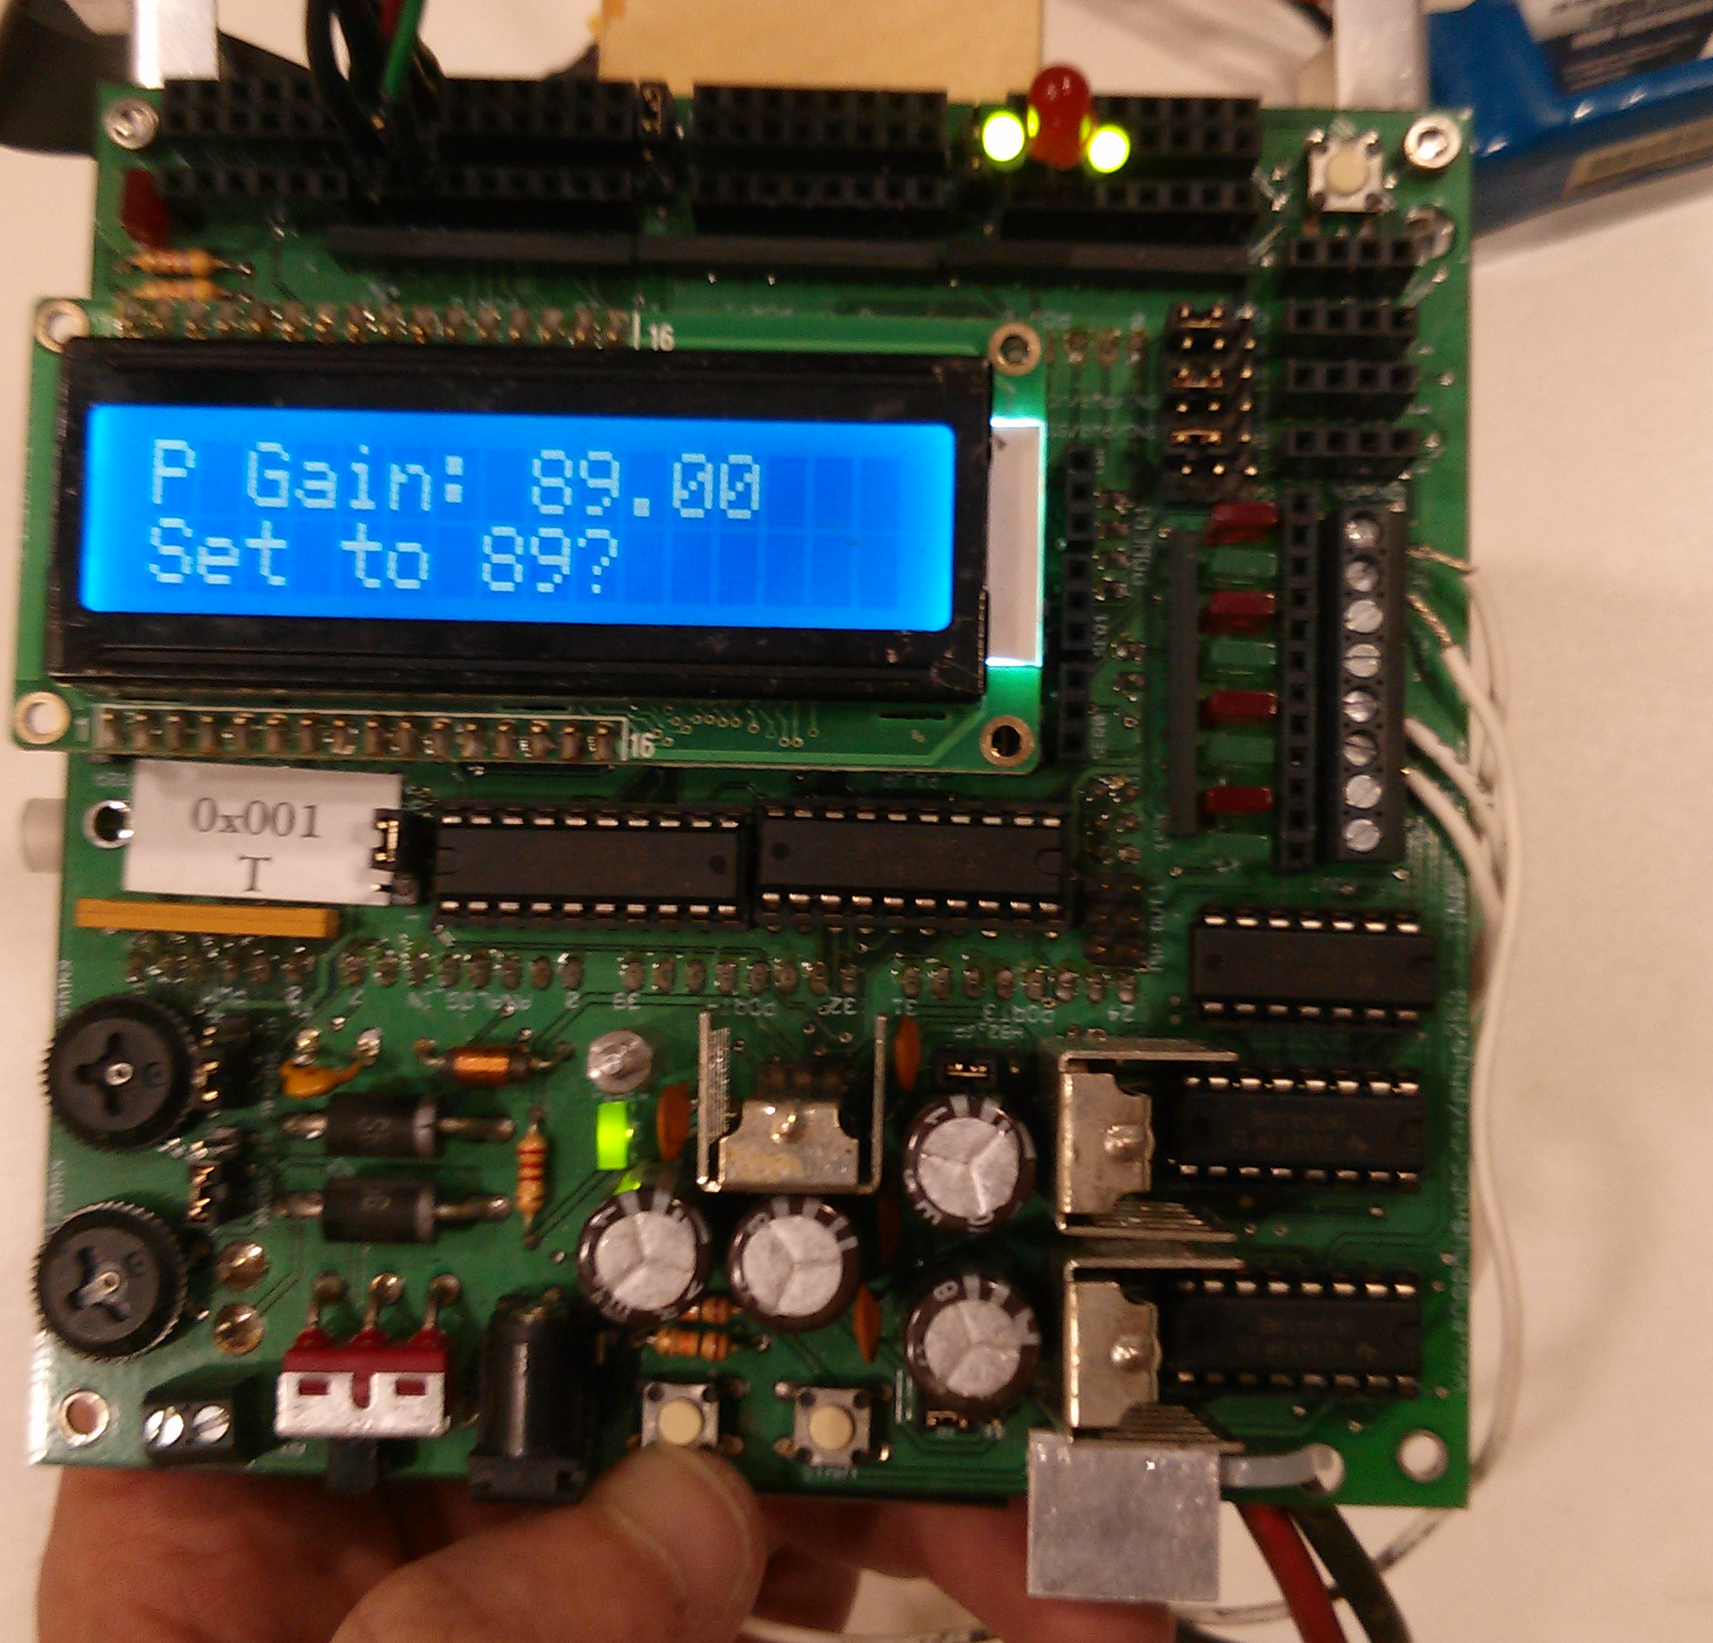

Figure . The bottom left button allows the user to confirm changes made to the tuning parameters

1. *P Gain* stands for *Proportional Gain.* Increasing this value will make the tape follower turn more sharply to compensate for veering off course. Decreasing this value will make the tape follower less sensitive to error.

*D Gain* stands for *Derivative Gain*. Larger values of derivative gain will increase the rate at which the robot reacts to errors in tape following. A value too large will cause the robot to oscillate and navigate erratically.

*Speed* represents the overall speed of the tape follower. Large speed values may be unstable and the tape follower may be too slow to react to error.

*Thresh* stands for *Threshold* and this represents the threshold amount of reflected light that the robot should consider to be tape. If this value is too low, everything will be considered tape. If it is too high, then nothing will be considered tape and the robot will be unable to navigate. It is good practice to set the threshold 5 units higher than the ambient white floor.

1. When the values have been tuned correctly, press the button on the bottom right of the TINAH. This will initiate navigation and the robot will begin to move. Place the robot on the tape with the sensors contacting the tape before you press this button. Figure 5 shows the location of the button. The navigation screen displays the raw infrared sensor values in the top line and the motor speed values in the bottom line. L and R indicate the left and right sensors respectively.

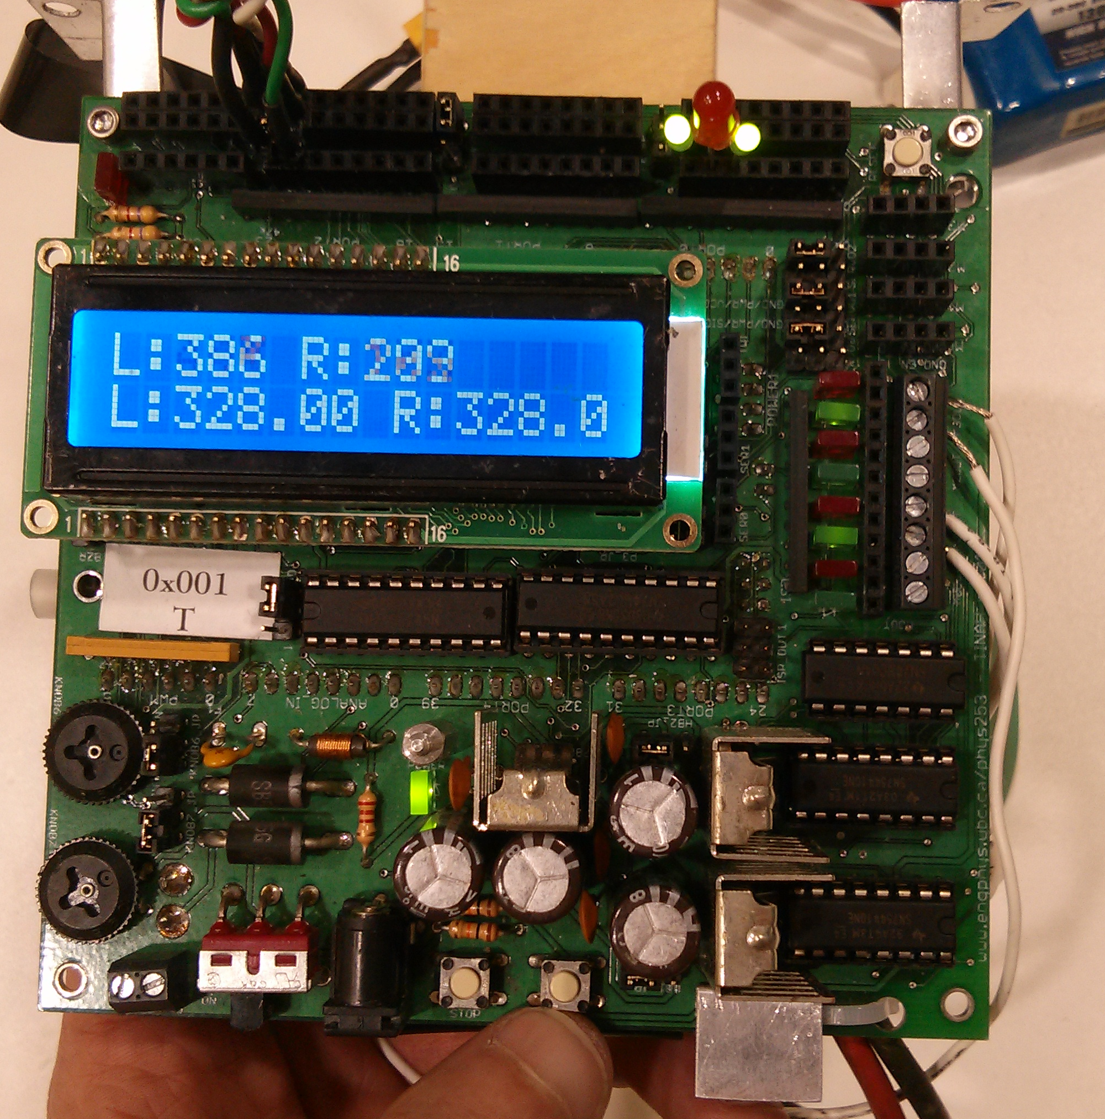

Figure . The bottom right button will confirm the settings and initialize the tape following sequence

1. Sensor placement is very important. The most accurate tape measurements occur when the sensors are placed in close proximity to the ground. It is good practice to ensure that the IR sensors are no more than 3 mm from the ground. The sensor location can be adjusted by bending the metal bracket that holds the sensors. The sensor bracket and IR sensors can be seen in Figure 6.

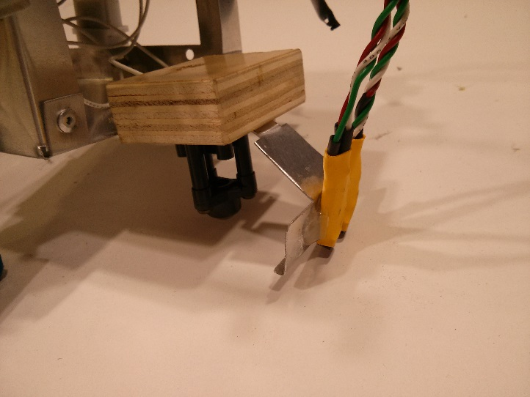

Figure The metal sensor bracket and can be bent and deformed to allow the sensors to be placed closer to the ground